TIME SERIES DATA ANALYSIS AND FORECAST METHODS

Lecture 6
Adaptive time series data analysis

Yekaterinburg
2017
Contents

Lecture purpose 3
Lecture map 3
Part 1. Adaptive data analysis of non-stationary time series 4
Part 2. Singular Spectrum Analysis (SSA) method 6
2.1. Этап разложения. Шаг вложения и шаг сингулярного разложения 7
2.2. Этап восстановления. Шаг группировки и шаг усреднения 8
2.3. Выбор способа группировки компонент в методе «Гусеница» 11
2.4. Выбор длины окна L компонент в методе «Гусеница» 14
Part 3. Wavelet Decomposition of time series 16
3.1. Схема вейвлет-декомпозиции 17
3.2. Вейвлетная пакетная декомпозиция WPD 21
Part 4. Empirical Mode Decomposition 23
Part 5. Time-frequency characteristics of non-stationary time series 29
5.1. Спектрограмма 29
5.2. Мгновенная частота. Преобразование Гильберта 31
5.3. Метод прямой квадратуры 33
References 35

Lecture purpose
The purpose of this lecture is to study the methods of time series analysis which do not need the stationary properties from initial time series, or any other a priori information about the process. In this paper the adaptive methods, including the latest developments in this field, are presented in detail. Their practical description is emphasized, rather than their theoretical basis, because of time series adaptive analysis nature.

Lecture map

- Definition of an adaptive time series analysis
- Non-stationary time series data analysis
- Singular Spectrum Analysis (SSA) method
- Wavelet Decomposition and Wavelet Packet Decomposition (WPD)
- Empirical Mode Decomposition (EMD) and modifications
- Spectrogram methods for time-frequency characteristics estimations
- Other methods for time-frequency characteristics estimations

Part 1. Adaptive data analysis of non-stationary time series
All of the methods for time series analysis, described before, relied on the stationarity of the time series and corresponding model. Let's remind that in a wide sense stationary time series have a time-independent expectation value and variance (and any other statistics). Otherwise, the time series can be considered as non-stationary.
What in general means dependence on time for selection of accidental process? It means that in each point of a temporary grid in which was we observe counting of TS, value of its any characteristic will depend on this moment of observation. In practice, components which have parameters and characteristics (including a mat have most TS waiting and dispersion) depend on time and are functions from time. For their description it is necessary to use not mean values, and some instantaneous values, that is such which unambiguously are defined in the set counting of a temporary grid. Therefore and instead of assessment of mean values for the analysis of non-stationary time series it will be necessary to build estimates of time-and-frequency characteristics making their component.
Generally speaking, the class of non-stationary processes and a class of processes with the changing time-and-frequency characteristics, do not match, their equivalence theoretically is still not proved. But it is authentically known that all non-stationary TS have the changing frequency time response characteristics, the return is not right. How then it is possible to analyze and, the main thing, to decompose similar non-stationary ranks?
The special class of the methods called by methods of adaptive time series analysis is engaged in the analysis of non-stationary time series. These types of methods do not demand from initial TS any assumptions about its stationary property, as well as any a priori knowledge of its properties in general.
From where the adjective “adaptive” in the name of these methods undertook? For the first time this term for designation of the whole class of the methods which are engaged in the analysis of NVR was offered by N. Huang in 1998. Behind this name the following explanation lies. Adaptive methods are designed to decompose and analyze properties of TS with the parameters changing in time. It is necessary for operational tracking of these changes, that also methods could adapt without intervention of the person the parameters, a technique and creation of an algorithm directly on the course of the analysis of TS. For achievement of these conditions, adaptive methods as we will see, have very small number of initial parameters (no more than 2), and all necessary criteria and estimates build on the basis of the character which is most analyzed by TS and its component.
With respect thereto adaptive methods of the analysis are very effectively applicable, including, and for the analysis of stationary time series. Moreover, as they have obviously less than the parameters, than at similar stationary methods, they can be used much quicker for initial assessment of parameters, divisibility, number a component and their structure in a row. For this reason all methods presented here were widely adopted very much as universal remedies of the analysis and decomposition of time series.

Part 2. Singular Spectrum Analysis (SSA) method
One of the key adaptive methods is the so-called method of Singular Spectrum Analysis (SSA). Thanks to Golyandina N. E. in Russian-speaking literature the method received the name “Caterpillar”. We will prefer to use the abbreviation SSA.
The SSA method is based on conversion of a one-dimensional time series in multidimensional by means of the parametrical shift procedure (thus the name “Caterpillar”) with the subsequent application to a multidimensional time series of a method main the PCA component (Principal component analysis). At the same time there is a research of the received multidimensional trajectories by means of singular decomposition and recovery approximations) of a row on the selected main components. The purpose of a method is decomposition of a time series on the interpreted additive components. At the same time the SSA method does not demand stationarity analyzed by TS, knowledge of model of a trend, and also data on existence in a number of periodic components and their periods that is very convenient in the analysis difficult to TS. It is only important to note that, nevertheless, initial model used in the SSA method is after all additive.
Let N > 2. Consider a real-valued time series 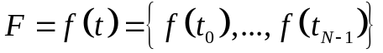 of length N, 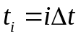. Assume that F is a nonzero series; that is, there exists at least one i such that f_{i} ≠ 0. Though one can usually assume that f_{i} = f(i∆t) for a certain function of time f(t) and a certain time interval ∆t. Moreover, the numbers 0, ..., N−1 can be interpreted not only as discrete time moments but also as labels of any other linearly ordered structure. Basic SSA consists of two complementary stages: decomposition and reconstruction.

2.1. Decomposition stage: embedding and singular value decomposition
The embedding procedure maps the original time series to a sequence of multidimensional lagged vectors. Let L be an integer (window length), 1 < L < N. The embedding procedure forms K = N – L + 1 lagged vectors
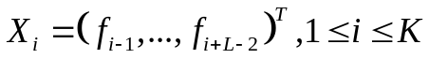 (6.1)
which have dimension L. If we need to emphasize the dimension of the X_{i}, then we shall call them L-lagged vectors.
X is a trajectory matrix of time series F and consists of those L-lagged vectors 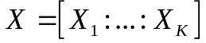. It can be represented as:
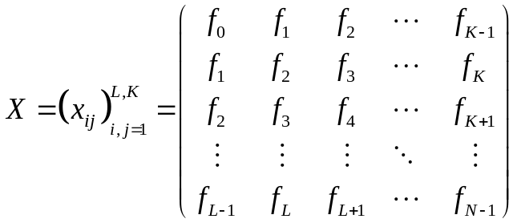 (6.2)
Obviously x_{ij} = f_{i+j−2} and the matrix X has equal elements on the diagonals i+j=const. Certainly, if N and L are fixed, then there is a unique correspondence between the trajectory matrices and the time series.
On the next step of decomposition we construct the Singular Value Decomposition = SVD of this trajectory matrix. Let 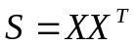. Denote by 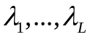the eigen values of S taken in the decreasing order of magnitude 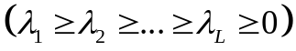 and by 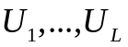 the orthonormal system of the eigen vectors of the matrix S corresponding to these eigen values.
Let d = max{i, such that λ_{i} >0}. If we denote 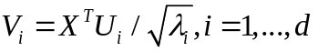, then the SVD of the trajectory matrix X can be written as
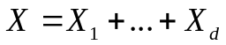 , (6.3)
where 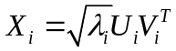. The collection 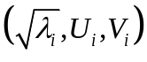 will be called i-th eigen-triplet.

2.2. Reconstruction stage: grouping and diagonal averaging procedure
Once the expansion (6.3) has been obtained, the grouping procedure partitions the set of indices {1, ..., d} into m disjoint subsets 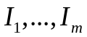.
Let 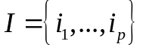. Then the resultant matrix X_{I} corresponding to the group I is defined as 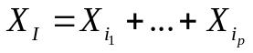. These matrices are computed for 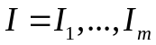 and the expansion (6.3) leads to the new decomposition. The procedure of choosing the sets I₁,...,I_{m} is called the eigen-triplet grouping.
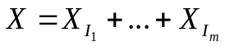 (6.4)
This step contains the most number of errors in SSA algorithm, because it is hard to establish the unique group, corresponding to the desired model, based only on initial data time series.
The last step in SSA transforms each matrix of the grouped decomposition (6.4) into a new series of length N.
Let Y be an L × K matrix with elements 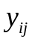, 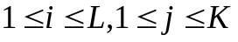. We set 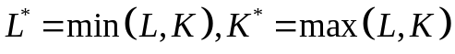 and 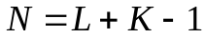.
Let 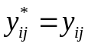 if 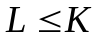and 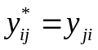 otherwise.
Diagonal averaging transfers the matrix Y to the series 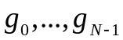 with (6.5):
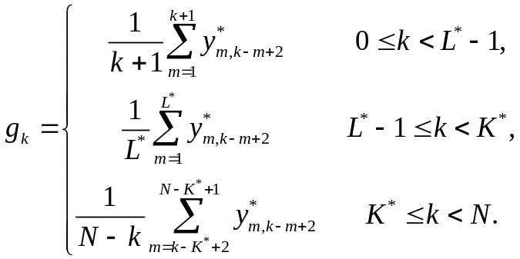 (6.5)

The expression (6.5) corresponds to averaging of the matrix elements over the diagonals 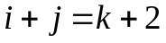: the choice k=0 gives 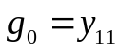, for k=1 we have 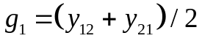, and so on. Note that if the matrix Y is the trajectory matrix of some series 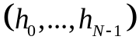, then 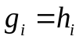 for all i.
Diagonal averaging (6.5) applied to a resultant matrix produces the series 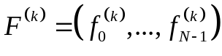 and therefore the initial series 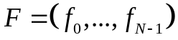 is decomposed into the sum of m series like 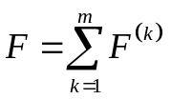.
If every component is exactly separable and their corresponding eigen-triplets are grouped accordingly, than all of matrices in (6.4) are Hankel matrices, thus making the perfect decomposition. In practice, there are some minor deviations, thus diagonal averaging is needed to smooth the errors. That’s why we don’t use the exact inverse SVD of trajectory matrices.
The step of grouping is very closely connected with a concept of separability of TS, which we considered earlier. Taking into account determinations of types of divisibility, stated above, it was mathematically established that at exact separability for SSA method is capable to decompose TS only into set of constant (average level) and strictly harmonic components. At asymptotic separability the situation significantly improves – only long-term trends cannot be broken into components. And the most important that at asymptotic separability, there is possible separation of the deterministic and stochastic components. At approximate separability it is possible to decompose TS into the smallest details.
For the SSA method there is one obvious parameter – the window L length, and not so obvious parameter – a method of grouping of eigen-triplets (6.4). Both of these parameters have to be selected on the basis of initial data time series.

2.3. How to choose the grouping subsets in the SSA technique
At first we will find a grouping method for components. Let a window be fixed and equal to L. We have got the trajectory matrix and corresponding eigen-triplets. Now, how do we select the indices from them?
There are several properties of grouping which will help us:
- The higher the value of eigen-value, the higher the contribution of the corresponding component to the total energy of process;
- Eigen-values are always in descending order;
- Harmonic eigen-vectors generate trigonometric components;
- Singular eigen-triples diagrams with regular form or pattern have a higher chance for a mutual grouping between each other;
- Single big eigen-values are related to trend;
- Double paired almost equal eigen-values are related to seasons;
- Close numerically eigen-values are related to modulated cycles;
- All of the residual components are considered the noise.
In general, the technique of grouping looks rather bulky. In the simplified modification of the SSA method called as Auto-SSA, all this technique is completely replaced with the automated means of the analysis of a periodogramma of data on the basis of which the most significant periods of components are defined, and on this basis the grouping is staged.
There are also other techniques of grouping a component: on the basis of singular numbers, on the basis of w-correlations, etc. You can familiarize yourself with them on your own with reference [1].

2.4. How to choose the window length L

Length of a window L is the key parameter to the SSA algorithm. The choice of a window has to depend on the data obviously. Let's consider at first the general choice rules of window L:

- There is no meaning to choose window length L larger than half of time series length N;
- The more the window L – the more basic components you will get, and the more detailed decomposition is built;
- Too small window L can lead to the mode mixing;
- In order to separate the periodic component with higher accuracy, it is essential to choose the window L as a multiple of this period;

One of the best techniques to select the window L was created by Fuad Rabaia, based on the difference between consecutive eigen-values, represented with these steps:
- For the initial time series window L is chosen between 10-20 time samples to the half of N; 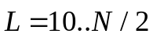
- For each corresponding value of L the difference between consecutive eigen-values is calculated. 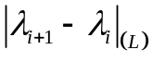
- Plot these differences as functions from window L for every pair of consecutive eigen-values.
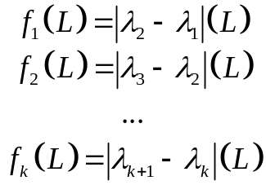
- The window L is chosen by the minimization of the difference between consecutive pair of eigen-values, considering all of them together;
- Periodic components will have the same period, as the plotted functions;
- The consecutive pair of eigen-values, which are not for grouping, will have non-periodic form of monotonic functions;

Thus, the effective technique was developed for the SSA method, which allows to apply it as adaptive means for the analysis of non-stationary and stationary time series. As we will see further, this method can be used also for the forecast of time series.

Part 3. Wavelet Decomposition of time series
Wavelet transform has been established and used already for a long period of time, but it became active for the analysis of TS, both stationary, and non-stationary, at the end of the 20th century. It already managed to prove itself in other areas as effective means for a solution of the whole class of the tasks connected with noise cancellation, compression of data, processing and synthesis of signals, the analysis of images, etc.
Wavelet transform is very similar in character to Fourier transform therefore the technique of its use reminds the spectrum methods. The main difference of these two conversions is that Fourier transform uses as basis harmonic functions of fixed frequency, and here wavelet transform – the whole class of different basic functions of different scale and localization on time (wavelets). Properties of process are represented at the same time both in frequency and in time grid, therefore the similar type of methods are called the time-and-frequency localization techniques.
The theoretical basis of any wavelet-analysis is defined by expression of Continuous Wavelet Transform - CWT:
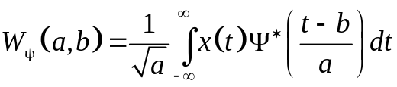 (6.6)
where a – is a scaling parameter, b – corresponds to temporary shift, 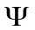 – mother-wavelet or basis of wavelet transform. Variations of a and b give us the time-and-frequency representation of data.
For expression (6.6) there is an obvious inverse transform:
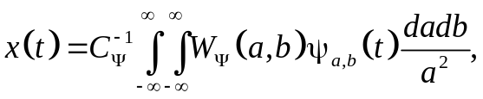 (6.7)
where 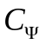 – constant based on 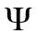: 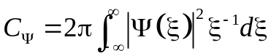.

3.1. Wavelet decomposition scheme
For a practical use we need not a continuous representation of wavelets, but rather their discrete form, such as Discrete Wavelet Transform – DWT:
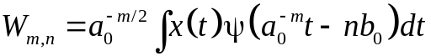 (6.8) 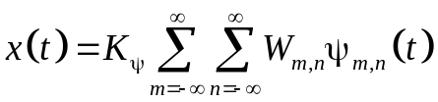 (6.9)
where m and n – integers, 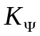 – normalization coefficient.
Expression (6.9) is already very similar to representation of initial TS in the form of additive mix of components from additive model. It is necessary to carry out the choice of 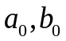 and basis wavelet 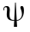. On practice DWT is based on orthonormal basis wavelets 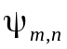[2].
The time series decomposition procedure is often created as an iteration filter scheme based on orthonormal basis wavelet functions, because the (6.8) expression is very similar to the Fourier convolution scheme.
Initial time series x(t) passes through the low-pass filter with impulse response g, and through the high-pass filter with impulse response ℎ, leading to the convolution product:
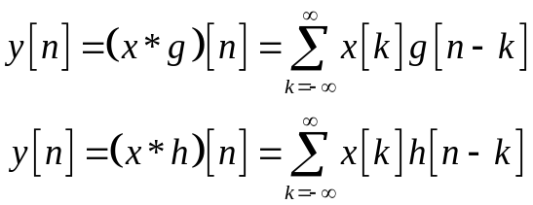 (6.10)

Those filters are linked with each other, and they are called Quadrature Mirror Filters (QMF). As the result of those filters we will receive the detail coefficients 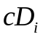 (from high-pass) and the approximation coefficients 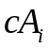 (from low-pass).

Because half of the frequency band was filtered, due to the Nyquist–Shannon sampling theorem we can decimate the time series by down-sampling:

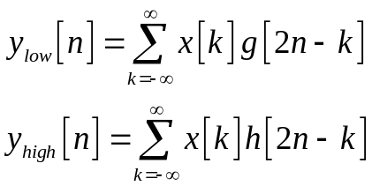 (6.11)

The very first step of this scheme (6.10)-(6.11) is presented below.
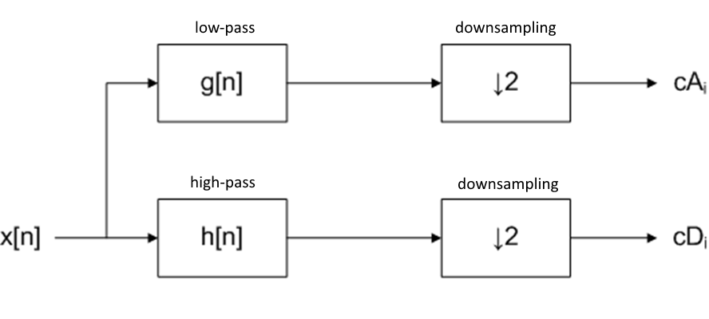
Figure 6.1 – Basic wavelet decomposition on level 1 (6.11)

On the next step we use the convolution product again on the detail coefficients , thus creating the binary tree of decomposition (fig. 6.2). This tree has several levels, its leaves and nodes correspond to spaces with different time-and-frequency localization. Varying number of cascades, it is possible to receive different number of the detail coefficients and, changing the level of decomposition of an initial time series, approximation coefficients .

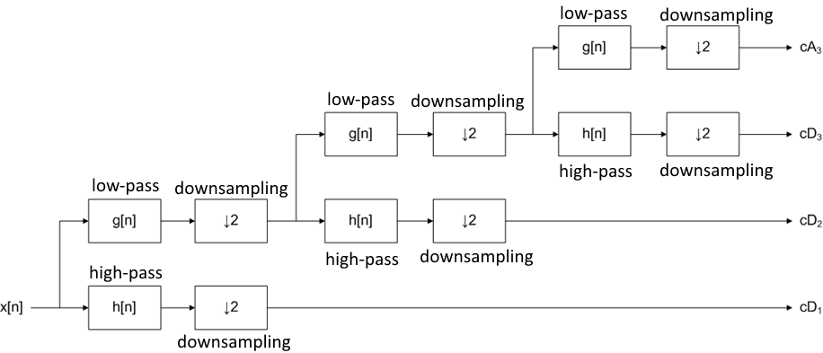
Figure 6.2 – Three levels of wavelet decomposition

Despite the seeming complexity of such scheme of decomposition of time series, its implementation turns out rather simple and, most importantly, very fast. Nevertheless, pure wavelet-decomposition on the basis of DWT has several shortcomings. First of all, the existence of only one direction for decomposition. That is, without change of basic parameters of a wavelet, other decomposition cannot be achieved. Unlike similar decomposition techniques for non-stationary TS where there is a grouping stage of components, here we will not be able to adapt the received result to required model. Secondly, the found values of coefficients of approximation and details theoretically are not always optimum. All these problems, as we will see further, are somewhat solved with Wavelet Packet Decomposition - WPD.

3.2. Wavelet Packet Decomposition WPD
Wavelet Packet Decomposition WPD is an upgraded version of DWT with several essential details:
- Repeated convolution and filtering can be applied not only to the detail coefficients cD, but to the approximation coefficients cA as well, thus leading to the reconstruction of the full binary tree (see fig. 6.3).
- From this full binary tree we can choose only one branch with the highest value of estimated entropy.
- Basis mother wavelet is chosen in such manner, that its derived wavelets can be calculated even before the binary tree reconstruction, thus making the wavelet transform even faster, approximately 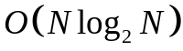.
- Scale and shift values are chosen adaptively, in order to achieve the decomposition with the highest accuracy.
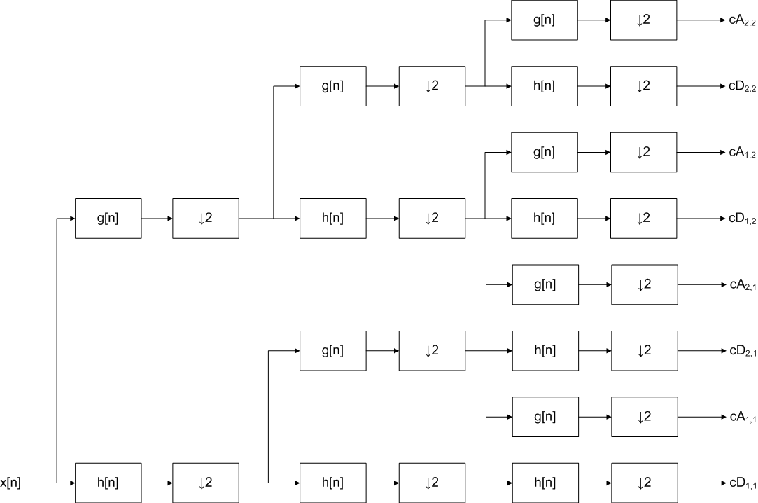
Figure 6.3 – Level 3 full binary tree for WPD

Part 4. Empirical Mode Decomposition
One of the newest methods of time series decomposition which do not require the stationarity from the data is the method of Empirical Mode Decomposition = EMD and its modifications.
Method EMD in its basis is very similar to the SSA: any time series 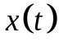 can be decomposed into the additive sum (6.12) of components (or modes) 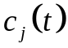 and the residual stochastic series 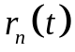.
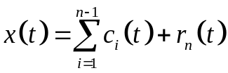 (6.12)
Every mode is an intrinsic function of initial time series and includes some information about generating process. The set of those modes can be even not orthonormal (as in SSA or WPD methods), thus making the EMD technique truly an adaptive time series analysis method. Similarly to wavelet transform, the modes can be compared to the Fourier basis, but instead they can have the amplitude and frequency modulations, thus representing the time series in time-and-frequency localization.
The core of EMD is based on empirical estimation of enveloping curves (upper curve U and lower curve L) with cubic splines, constructed through maximum and minimum points of time series. Arithmetical mean m of those enveloping curves then is removed from analyzed data; thereupon received residual r is subjected to this enveloping procedure again, until calculated residual r fits with certain criteria and then noted as found intrinsic component c_{i}. By removing found component c_{i} from initial time series u₀(t) we obtain new time series u(t) to decompose iteratively, based on the (6.12) definition. This decomposition is repeated until residual r_{n}(t) is a monotonic function. Overall scheme for this algorithm is shown on figure 6.4.

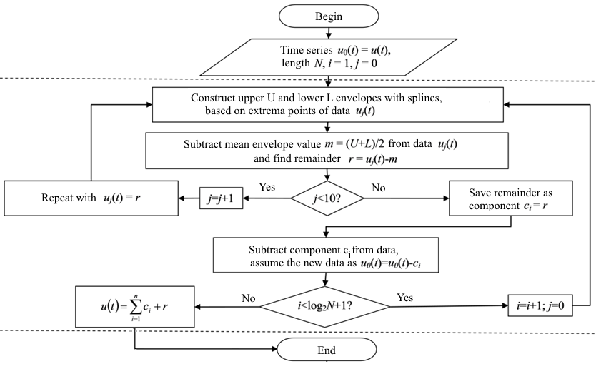
Figure 6.4 – Empirical Mode Decomposition

In the sequential order, the EMD can be represented as follows:
- Search out all of the max and min points of the initial time series ;
- Build the two enveloping interpolating curves with cubic splines, passing through these maximum and minimum points of the time series;
- The upper curve (passing through the maximums) is noted as U, the lower curve (passing through the minimums) is noted as L.
- Estimate the arithmetical mean curve 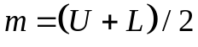;
- Remove this mean curve from data: 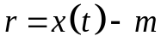.
- Repeat the steps 1-5 for ten times (or until this arithmetical mean curve m is not close to zero);
- The final residue 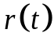 is accepted as the found component or intrinsic mode 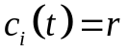, where i – is the sequential number of component.
- This found mode 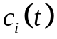 is removed from time series;
- The residual denoted as the new time series 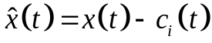 that is needed to be decomposed iteratively with the previous steps of EMD procedure;
- Go to step 1. Repeat these steps n times, where n – is the number of components and estimated as 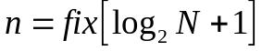.

As you can see there is almost none theory in EMD technique, only splines and search methods, making it rather fast and simple for realization. Let's review the simplest bright example of decomposition of data with EMD. We have the time series represented as sum of 4 harmonic signals with different frequencies. From decomposition we would expect the exact 4 components with zero residual. The number of components is based on the length of time series, thus we will receive more components than needed. In this case we need to group them in order to achieve the best results (something similar to the grouping of the SSA method).
In our case everything turns out rather simply: the 4 harmonic components are selected from the first 4 steps of decomposition, and all subsequent modes, compensating each other, are summed up in the residual data close to zero. The received decomposition is presented in the figure 6.5a. Apparently from it, the result is positive, but on practice such ideal picture is not achievable, because of the noise corruption, thus breaking the properties of the exact separability.

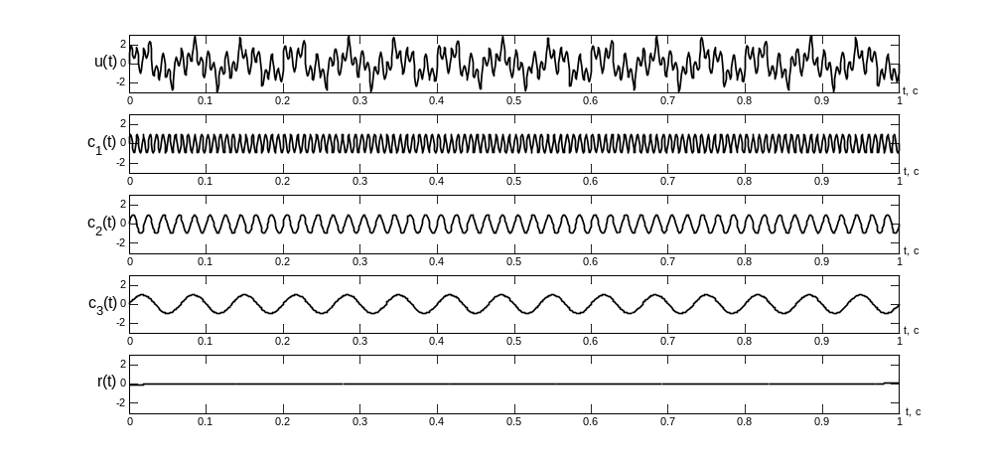
Figure 6.5a – Initial time series, its 4 components and the residual data
The main problem of the EMD algorithm is the mode mixing effect problem. The strong separability is unattainable if the initial time series has a considerable noise, thus the found modes/components are distorted due to the mixing of frequency bands (see fig. 6.5b). Also, it makes so that the residual stochastic time series data does not qualifies as a random variable with statistical tests.
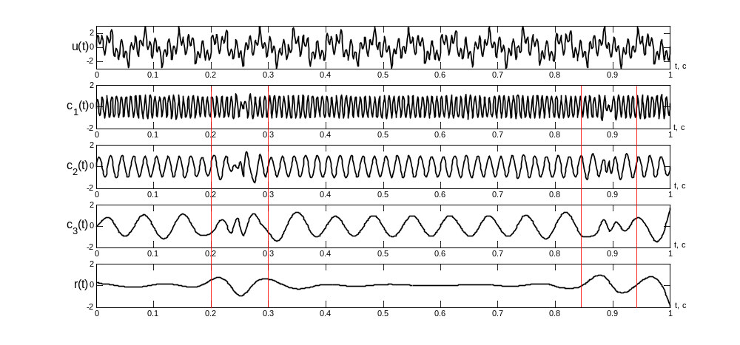
Figure 6.5b – Mode Mixing Effect
Mode mixing effect was partially solved in the next modification of EMD, called the Ensemble EMD = EEMD. It was proved, that when adding the white Gaussian noise (wGn) to the initial time series, its components will be reconstructed in strict frequency-band order of dyadic filtering, thus eliminating the mixing problem in most cases. But with added noise we make the data less accurate. The consequences of this disadvantage are partially compensated by the usage of Monte-Carlo technique, because the final modes are not distorted and mixed due to the ensemble filtering and averaging procedure.
Procedure EEMD is a more complex version of EMD. In contrast to EMD, overall decomposition is applied to initial time series u₀(t) not only once, but several N_{E} (Ensemble Number) times. Also, in order to achieve initial discrepancy of time series for the subsequent ensemble averaging procedure, white Gaussian noise (wGn) with known signal-to-noise ratio SN_{E} is added to the initial data u₀(t).
In sequential order this algorithm (see fig. 6.6) is represented below
- For a time series u(t) of length N we estimate the number of modes .
- Normalize the initial time series 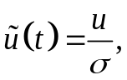 where
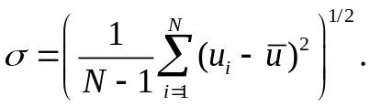
- Determine the two input parameters: the ensemble number N_{E}, and the added signal-to-noise ratio SN_{E}
Default values are: 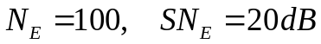
- Add to the normalized data a noise sample with the known signal-to-noise ratio SN_{E} 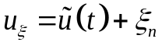
- Decompose this time series 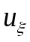 with EMD.
- Repeat these steps 4 & 5 N_{E} times. On every iteration of this outer cycle the decomposition is saved, and the noise sample is re-generated.
- Ensemble averaging procedure is then used on the achieved decomposition, and then the final modes are de-normalized. 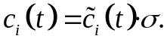

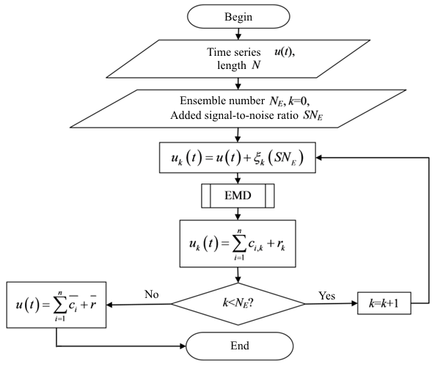
Figure 6.6 – Ensemble Empirical Mode Decomposition

There is even newer version of EEMD technique, called Complementary EEMD = CEEMD, where on the 4th step of an algorithm two subsets of components are created – with “plus” added noise sample and with “minus” added the same noise sample. The final ensemble averaging would be much more accurate and precise due to the symmetry of this scheme.
For today among all set of modifications the CEEMD is the most accurate and effective technique for adaptive decomposition. The main CEEMD disadvantage is its slow speed of order 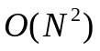. In present time, there are already several methods, created to increase the speed of CEEMD up to the 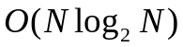, including some complex decisions with parallel computing on GPU. The future of this empirical decomposition is bright and is still developing.

Part 5. Time-frequency characteristics of non-stationary time series
As it was possible to notice by the description of the above listed methods, all of them make an adaptive decomposition of time series. But we are still interested in the properties of those found components, even though they have some specific, even non-stationary properties.
The best means of the analysis for harmonic series is the creation of their spectrum. But if the frequency is the function of time (non-stationary data), then spectrum means nothing. Still we want something as simple as spectrum methods for the time-and-frequency localization representation. This idea formed the basis of the first implementations on a method of creation for time-and-frequency characteristics of time series.

5.1. Spectrogram
The simple Fourier transform (and all the derivative spectrum methods) has a fixed frequency resolution, and the frequencies are integrated throughout the entire time interval. However, with window convolutions we can decompose the time series into small time spans with quasi-constant frequencies, thus reconstructing the time-and-frequency characteristic of time series data:
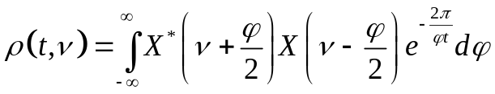 (6.13)
This method of window convolutions of Fourier transform with fixed time spans is called spectrogram and gives us the estimation of time-and-frequency localization for time series.
Spectrogram is shown on figure 6.7 for the chirp signal with linear frequency from 1 to 300 Hz in 2 seconds time span. It is evident, that we can clearly see the linearity of frequency modulation and the corresponding border values.

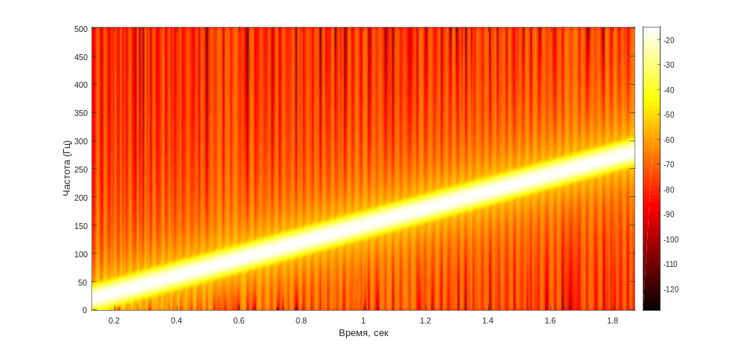
Figure 6.7 – Chirp signal spectrogram

Due to the FFT, spectrogram is fast and easily implemented in any software. But why is it only the estimation? There are several problems. First of all, the window time spans are fixed and constant, making it impossible to change the scale of localization as we wish. Secondly, time-and-frequency localization is always limited by the Nyquist-Shannon theorem, making it finite and fixed. There are also many other similar problems, thus the scientists needed to find some other similar methods, but with more accuracy.

5.2. Instantaneous frequency. Hilbert transform

The fact that in time series components, which have a period and, respectively, a frequency can be the functions of time, was known at the beginning of the 20th century. In relation to time series, we need to specify the corresponding value of the period/frequency in each point of a temporary grid on which it is defined by TS. Therefore such representation of the period/frequency in the form of function of time is called instantaneous period / instantaneous frequency. As both of these concepts are biunique, we will use only a concept of instant frequency further.
The problem with instant frequency is that data should define it unambiguously at any given moment theoretically. For this reason in 1946 Gabor offered and defined a concept of an analytical signal. Analytical signal allows introducing simple and unambiguous definitions for amplitude a(t), phase φ(t) and instantaneous frequency ω(t) of signal u(t).

Based on Gabor analytical signal w(t) is defined as
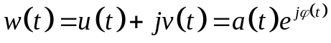 (6.14)
where 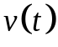 – signal, conjugated to initial data u(t) with Hilbert transform:
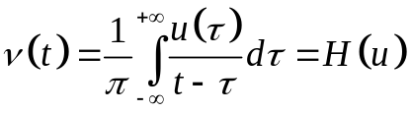 (6.15)

With the introduction of analytical signal w(t) with the help of Hilbert transform H(u), we can calculate any instantaneous characteristic as a function of time.
Enveloping curve (amplitude modulation):
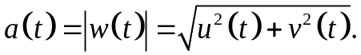 (6.16)
Instantaneous phase:
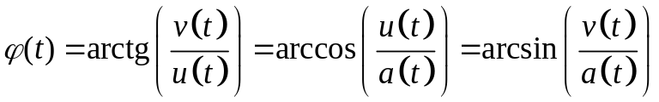 . (6.17)
and Instantaneous frequency:
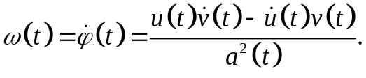 (6.18)

It should be noted that an instantaneous frequency is calculated as a derivative, thus the accuracy of its calculation will be influenced by methods of differentiation, values of an initial data and methods of enveloping estimations.

Turns out, after any adaptive decomposition of initial time series (with SSA, WPD, EMD or any other method) we can represent the results in time-and-frequency representation with instantaneous frequencies / instantaneous periods as functions of time in pure form with the maximum available accuracy for a given time grid. Equations (6.15) – (6.18) make the basis of every modern technique for the time-and-frequency spectrum. Variations are based on differential methods, enveloping methods and Hilbert transform estimations.
With this many benefits of this method, there are several crippling disadvantages. First of all, the instantaneous functions are always have the boundary effect, with distortions on the edges of time span. Secondly, differentiation procedure is always computationally unstable, creating the zeros and infinite values in the final results. For now, Hilbert transform is still the most effective method of time-and-frequency representation.

5.3. Direct Quadrature
Quite recently (2010) one more method for the instantaneous frequency estimation was introduced, called the Direct Quadrature (DQ). The DQ method is purely empirical (as the EMD) and, though its accuracy is rather low, it still can quite serve for the initial estimation of time-and-frequency characteristics of time series, especially for the low-frequency band modes, cycles and periodics.
The technique of this approach is rather similar to the EMD:

- Create the time series of absolute values of initial data 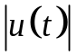.
- Create the enveloping curve with cubic splines 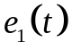, passing through the maximums of , the same as we did it in EMD.
- Divide the initial time series by this enveloping curve 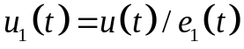.
- Repeat this normalization (steps 2 & 3), until 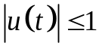.
The last iteration data time series is denoted as 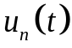.
- Estimate the amplitude modulation as 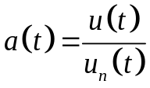.
- Estimate the Direct Quadrature as 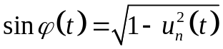.
- Estimate the instantaneous frequency with (6.17) and (6.18).

In the DQ method we estimate the analytical signal through empirical approximations. The benefits of this approach are its simplicity and speed. But for this the DQ pays with low accuracy.
Among similar evaluation methods of time-and-frequency characteristics it should be noted: generalized zero crossing – GZC method, teager energy operator – TEO method, and other similar techniques.

References

1. Golyandina, N., A. Zhigljavsky. Singular Spectrum Analysis for time series. — Springer Briefs in Statistics. — Springer. — 2013. — 120 p.
2. Amara Graps. An Introduction to Wavelets, IEEE Computational Sciences and Engineering. — Vol. 2. — No 2. —1995. — pp. 50-61.
3. Huang N. E. The Hilbert-Huang transform and its applications. Interdisciplinary mathematical sciences: World Scientific Publishing Company Co. Pte. Ltd. — 2005. —311 p. ISBN: 9812563768.
4. Huang N. E., Wu Z., Long S. R. On Instantaneous Frequency. — Advances in Adaptive Data Analysis. 2009. — 53 p.
5. Yeh J.R., Shieh J.S., Huang N.E. Complementary Ensemble Empirical Mode Decomposition: A Novel Noise Enhanced Data Analysis Method. — Advances in Adaptive Data Analysis. 2010. — Vol. 2, no. 2. — P. 135–156.
6. Bedrosian, E. (December 1962), A Product Theorem for Hilbert Transforms, Rand Corporation Memorandum (RM-3439-PR). https://www.rand.org/content/dam/rand/pubs/research_memoranda/2008/RM3439.pdf

